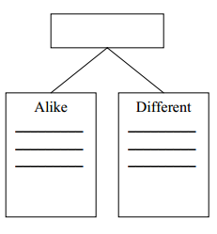[**lmayer@revere.mec.edu**](mailto:lmayer@revere.mec.edu)

Introduce:

* idea of **same** and **different** and connect to terms compare / contrast
* concept through thematic vocabulary
* organizational structure

Compare & Contrast

Compare & Contrast: Conceptual Level

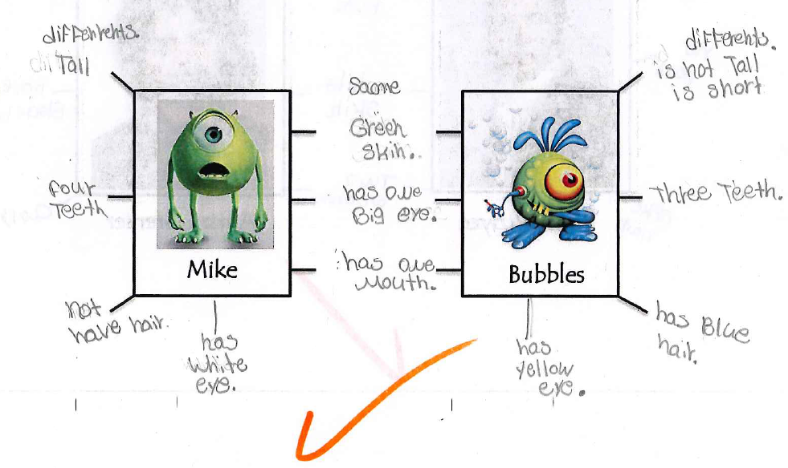



[**lmayer@revere.mec.edu**](mailto:lmayer@revere.mec.edu)

Use sentence frames to show students how they can combine their vocabulary with the signal words, using correct syntax, to form sentences that express their ideas.

Compare & Contrast

Compare & Contrast: Sentence Level



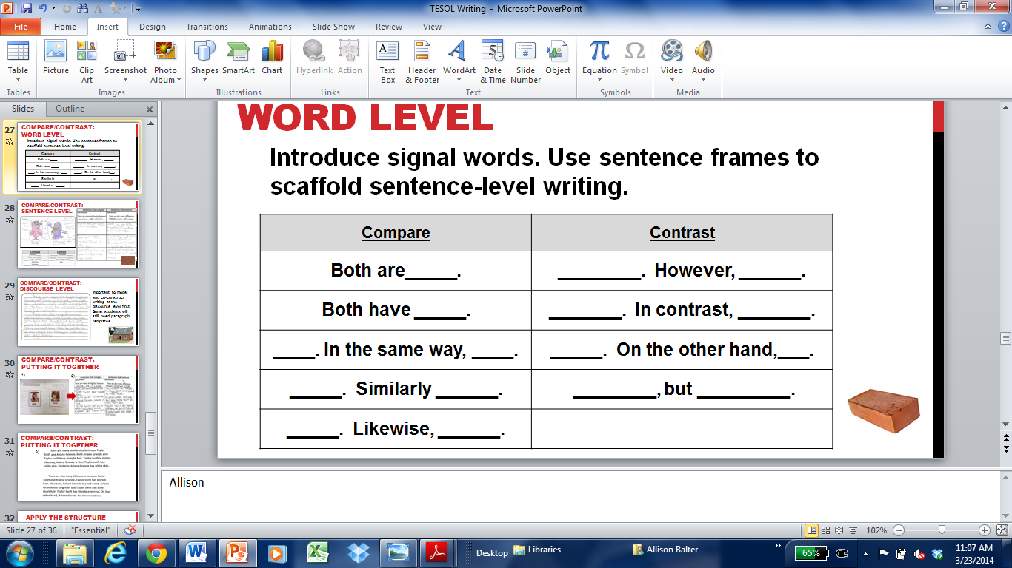

[**lmayer@revere.mec.edu**](mailto:lmayer@revere.mec.edu)

Model and co-construct writing at the discourse level first. Some students will still need paragraph templates.

Compare & Contrast

Compare & Contrast: Discourse Level

There are many similarities between _______ and _________. Both are ______________. _________ is __________. Similarly, __________ is _____________. __________ has _________. Likewise, ___________ has __________.

There are also many differences between ______ and ______. _______ has _______. In contrast, ________ does not have ______. _______ is _________. On the other hand, _______ is not _______. ________ has ________, but ________ does not have _________.

